**APPENDIX**

**Requirements & Market Study - Interview Transcripts**

**Participant 1: age 65-85**

**1. Are you a gardener? If so, what do you enjoy most about gardening?**

Yes, I enjoy gardening very much in particular growing my own vegetables to encourage my grandchildren to eat healthily. I find gardening therapeutic and it helps to keep me active. I also enjoying chatting with the neighbours.

**2. How often do you maintain your garden/vegetable patch? How do you maintain your garden/vegetable patch?**

I tend to the plants and vegetables in our community garden on a daily basis (weather permitting) by watering, pruning, weeding etc.

**3. Do you think an app providing garden information would be useful?**

Yes, an app would be useful as long as it is easy for me to access on my tablet and user friendly as I am not very confident on the computer.

**4. Would you find any of the following useful? If so, can you please explain why?**

* **A reminder/notification feature**
* **A drawing feature to plan out your garden i.e. where to place plants and crops**
* **A calendar marking key dates when to plant, prune or harvest**

Reminders would be helpful to me as I am quite forgetful.

**5. Can you think of any other useful features that you would like added to the app?**

Up to date weather notifications would be useful to save me from wasting time and water if it is going to rain. Useful tips to deter unwanted pests from ruining my vegetable patch.

**Participant 2: age 30-40**

**1. Are you a gardener? If so, what do you enjoy most about gardening?**

Yes, I like relaxing in my garden. I cut the grass and maintain a few shrubs. I also like visiting garden centres, particularly in the summer, and take pictures to get ideas for my flower pots and baskets? I also enjoy having barbecues with family and friends.

**2. How often do you maintain your garden/vegetable patch? How do you maintain your garden/vegetable patch?**

I work full time so am not able to maintain my garden as much as I would like and therefore keep it low maintenance.

**3. Do you think an app providing garden information would be useful?**

Yes, an app would save me an enormous amount of time giving me instant access to quick and simple information as I do not have much gardening experience.

**4. Would you find any of the following useful? If so, can you please explain why?**

* **A reminder/notification feature**
* **A drawing feature to plan out your garden i.e. where to place plants and crops**
* **A calendar marking key dates when to plant, prune or harvest**

They would all be great, the reminders and calendar will help me to keep track and motivated. I love the idea of the drawing app - it would be great to take a picture and actually be able to position it in my garden on a 3D scale.

**5. Can you think of any other useful features that you would like added to the app?**

I would describe myself as an artistic person and would find it really cool if there was a space on the app where people could add photos of their creations to get some inspiration.

**Testing Low Fidelity Prototypes With Stakeholders - Interview Transcripts**

**What are your thoughts on the home screen?**

*Stakeholder 1:*

The home screen looks very user-friendly. The layout is clear and simple and I would know where to go if I needed to access the calendar feature. I like that the icons are large enough so that when I’m in the garden I can clearly see and press the feature I need to access without accidentally pressing another feature which tends to happen when I use apps designed with small icons.

*Stakeholder 2:*

Nice design with a modern look. I like the horizontal layout and use of pictures and it is simple and easy to navigate. There could perhaps be a weather update or alert at the top of the screen so that if it’s going to be really hot that day, I will be reminded to water my plants.

*Stakeholder 3:*

I like the design a lot especially the use of large icons which means I don’t have to wear my glasses.

**What are your thoughts on the drawing feature?**

*Stakeholder* *1:*

I think that it looks professional and it would help me to plan out my garden. I like the selection of plants but think it would make the canvas size smaller making it even more difficult to draw on. If I am being completely honest, I wouldn’t have the patience to draw out the layout or specify measurements since I am not used to apps I would probably avoid using this feature as it seems too technical for me. This feature should be much easier to use. For example, simply dragging and dropping the plant in your garden and if I think it looks nice I will keep it there. I do like the alerts of plant requirements as this would help me to decide what plants I could have in my garden.

*Stakeholder 2:*

It looks okay. It isn’t what I expected, I expected more. To me it looks a little outdated and boring. I work full time and simply wouldn’t find the time or patience to map out my garden using the drawing tools and would get completely lost with the measurements. What I expected was to be able to hold up my tablet facing my garden (or an empty patch) and select a plant from the list provided and be told the best place to plant it. When I hover over the plant it should also give me facts about the plant as well as the requirements i.e. what soil is best, how many times it should be watered, how much maintenance is needed. If the drawing feature was changed to accommodate this, I would be much more excited about growing my garden. Otherwise I wouldn’t be motivated as it would feel more like a chore than a hobby.

*Stakeholder* *3:*

I’m not a huge fan of this feature, it looks too technical for me and I wouldn’t have the patience to draw on the blank canvas as I’m not a very good drawer. This wouldn’t help me and as a result I wouldn’t use this feature.

**What are your thoughts on the database of plants feature?**

*Stakeholder 1:*

I like it a lot, the layout looks clear and the search bar would make it much easier to navigate.

*Stakeholder 2:*

This would be invaluable to me, all the information I need would be in one place instead of having to search through the internet and find information on plants that aren’t always reliable. It would save me a huge amount of time.

*Stakeholder 3:*

Nice clear layout. The only feedback I have is that in the previous feature (drawing feature) you had a selection of plants already listed with the facts and plant requirements. This feature feels like an unnecessary duplicate. Perhaps this feature isn’t needed and could be merged into one and only displayed in the drawing feature?

**What are your thoughts on the calendar feature?**

*Stakeholder 1:*

Looks great, I like that you haven’t overcomplicated it and that it extracts any necessary information, turns them into reminders and plots them in the calendar - very clever would save me a lot of time and confusion!

*Stakeholder* *2:*

Exactly how I imagined it! Clear, user-friendly and sets handy reminders. No improvements needed here!

*Stakeholder* *3:*

This would make my life much easier! I am quite a forgetful person and for this app to sort out all of the reminders for me makes it more appealing. The only suggestion I have is what if it’s raining, would the app tell me that rather than having to waste my time and water resources?

**What are your thoughts on the forum feature?**

*Stakeholder 1:*

I think it’s a good idea, at first glance maybe it’s not for me. However the purpose of this feature sounds like it could help a lot of gardeners so I would be willing to use it if it is designed with elderly people in mind.

*Stakeholder 2:*

Just what I need and I am glad you looked into this after our previous interview. To have an online gardening community would be absolutely invaluable to me. I already know that when I start gardening, I would have a ton of questions however looking at your other features which provides concise relevant information I think I should be fine! Knowing there is a secure platform makes the idea of growing my garden more exciting!

*Stakeholder 3:*

This sounds like a good idea, not sure if I would use it but having extra gardening information would be handy.

**What are your overall thoughts on the app?**

*Stakeholder 1:*

I think it’s turning out to be a really good idea and possibly something I’ve been missing in all my gardening years! I like all the suggested features and cannot think of any more - these tick all the boxes. The only one that I wouldn’t find of any benefit at the moment is the drawing feature and hopefully my suggestion will be considered.

*Stakeholder 2:*

Seeing the early stages of this app has made me more excited about the prospect of growing my own garden. I am an inexperienced gardener but knowing I have this app to hand will hopefully make the experience more enjoyable i.e. the reminders, forum and database. To make this app even better, I strongly believe the drawing feature needs to be changed.

*Stakeholder 3:*

This app could be beneficial to a lot of people. As a gardener I hate the thought of plants and vegetables dying due to lack of maintenance and poor gardening decisions. A couple of days ago I read something online about how the rate of plant extinction has risen due to lack of care. As a plant enthusiast I think this is a great shame and that this app could really make a difference to stop this from happening. If this app is designed well, has a fresh modern look and has a more visual drawing feature I believe a lot more people would be willing to use it. Even if gardening just isn’t for them at least they’ll become more aware of the environment and the importance of caring for our ecosystem.

**“Study Finds Reasons for Plant Extinction Vary Across the World and Over Time” Article by the University of Tyumen November 6, 2019**

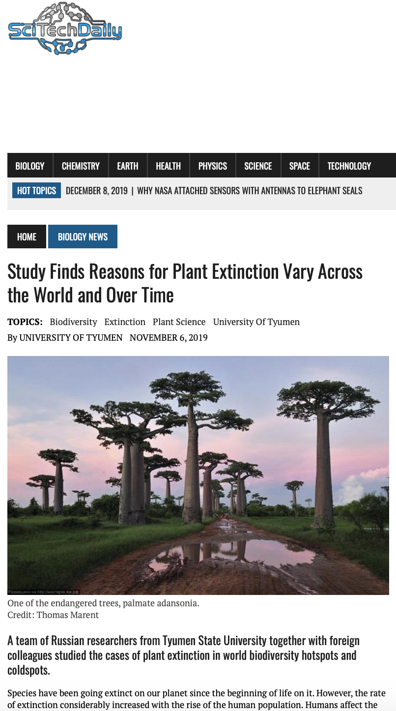

**Testing High Fidelity Prototypes With Stakeholders - Interview Transcripts**

**What are your thoughts on the home screen?**

*Stakeholder 1:*

The home screen has a clear user-friendly layout. Nice colours, modern appeal. I did notice grammatical errors which makes the app less professional.

*Stakeholder 2:*

Vibrant colours and easy to navigate. A few grammar errors which needs to be fixed. However the index page is really professional which makes this app even more appealing.

**What are your thoughts on the drawing feature?**

*Stakeholder* *1:*

This feature looks much better and I would definitely be able to use this. Before it seemed too complicated, especially for elderly people, but now I can just simply drag and drop a plant and see it in a 3D way.

*Stakeholder 2:*

I am thrilled that my previous comments were taken into account. The use of the grid is great as before you had to enter the measurements but now I can press a few buttons to change the grid layout. However the augmented reality part looks really impressive and was exactly what I imagined. This would definitely help me visualise my garden. The only feedback I have is that when I select a plant, a reminder should pop up and tell me whether the position is suitable.

**What are your thoughts on the database of plants feature?**

*Stakeholder 1:*

It looks great - clear layout, nice imagery, a fantastic resource.

*Stakeholder 2:*

I said it before but this would be invaluable to me. I like the use of pictures and the search bar to help me refine my results. This would save me an enormous amount of time knowing that all the information I need is in one place and is reliable.

**What are your thoughts on the calendar feature?**

*Stakeholder 1:*

Just how I imagined it – clear and easy to use. I would have liked to have seen how the reminders work, but now that you have explained to me how it would work, I am confident that this feature would be invaluable!

*Stakeholder* *2:*

It looks great, just what I need. I would like to see weather updates though.

**What are your thoughts on the forum feature?**

*Stakeholder 1:*

Again, I think it’s a great idea and I am glad that you listened to my feedback and designed it with elderly people in mind.

*Stakeholder 2:*

The layout is definitely user-friendly and having this extra gardening resource would be extremely helpful.

**What are your overall thoughts on the app?**

*Stakeholder 1:*

The progress made is excellent and exactly what I need to help me with my gardening tasks. This app could really make a difference.

*Stakeholder 2:*

This prototype is exactly what I imagined this app to be and I am excited to see what the final app will look like. The design style is consistent and the layout is easy to navigate. Now that the design feature has been improved and the app looks more modern, I think this app could appeal to more people.